IAM & ACCOUNT SECURITY SETUP
What I Built Today
Before spinning up any heavy infrastructure, I needed to put strict financial boundaries in place. Today was all about automating cost tracking and setting up billing alarms to prevent any unexpected AWS charges.
Why This Matters
Eventually, I will be deploying backends for my hardware builds, like processing data for the smart shopping cart or hosting the joystick-controlled wheelchair interface. Those services will consume real compute power. Setting up these alerts ensures that running my projects in the cloud stays completely sustainable and never exceeds my personal budget.
Step 1: Configuring AWS Budgets
I started by setting up a baseline budget from the AWS Billing dashboard.
- The Rules: I created a renewing Monthly Cost Budget.
- The Limit: I set the absolute maximum spend to $5.00.
- The Trigger: I configured an email alert to notify me the moment my actual usage hits 80% of that $5 budget.
Quick note: Once you create the budget, it takes up to 24 hours for AWS to gather the initial billing data and show it on the dashboard.
Step 2: CloudWatch Billing Alarms
After handling the high-level budget, I set up a more immediate alarm using Amazon CloudWatch.
- I navigated to CloudWatch and created an alarm tracking the EstimatedCharges metric.
- I linked this alarm to an Amazon SNS (Simple Notification Service) topic so that it pushes an alert straight to my inbox if the threshold is breached.
Gotchas & Troubleshooting
- The hidden toggle: I learned that CloudWatch will not track your money automatically. You have to go into your main Billing Preferences first and manually check the box for "Receive Billing Alerts" before the metric even becomes visible in CloudWatch.
Proof of Work
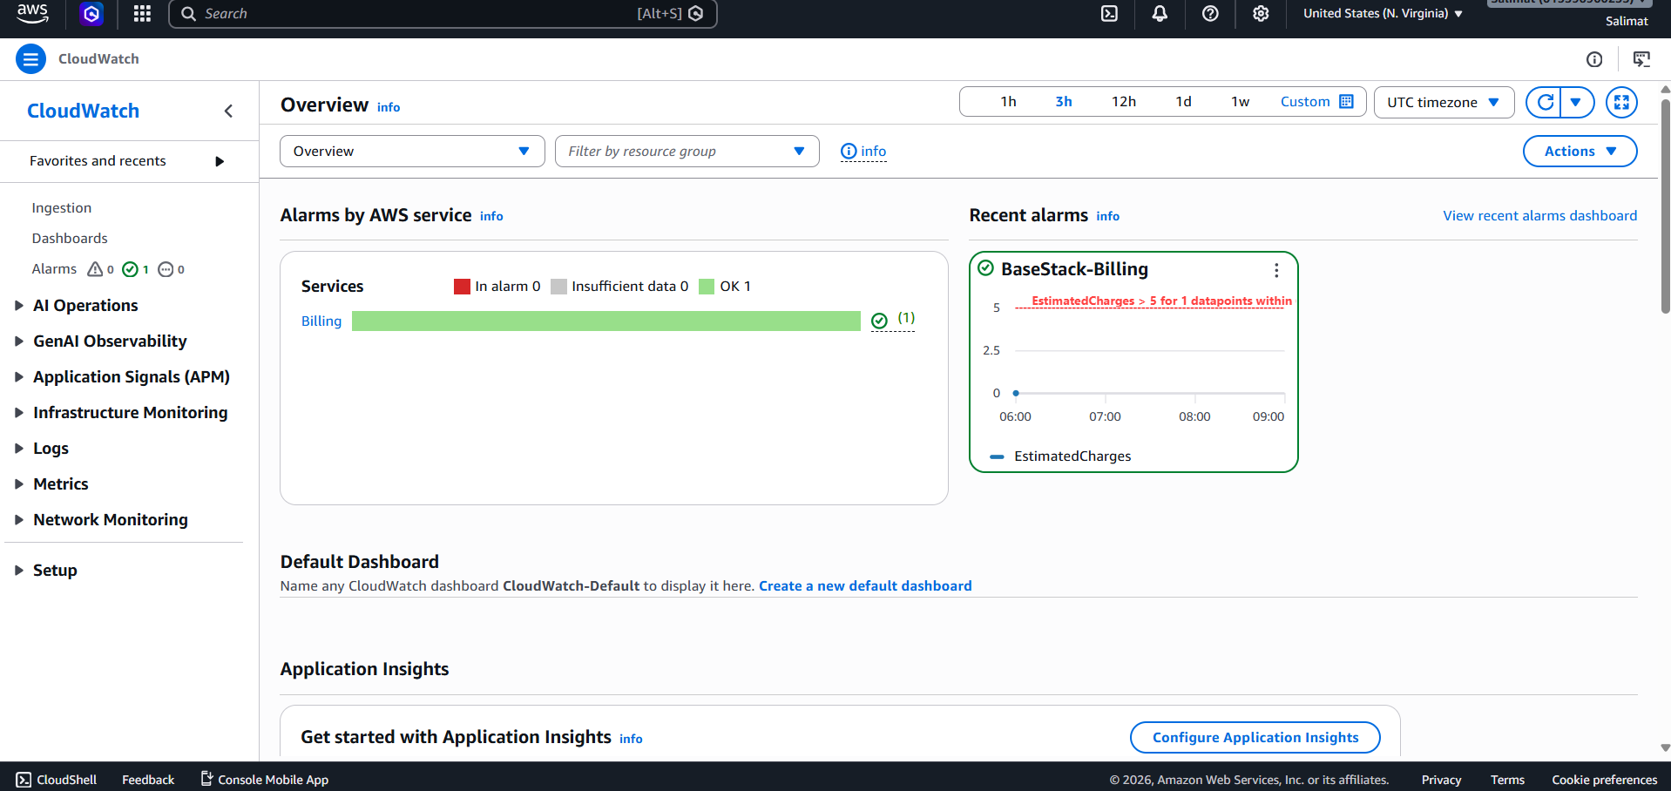
6. Sign in to the IAM User AWS Console
